SUPERIOR UNIVERSITY LAHORE


Faculty of Computer Science & IT

Final Year Project
PROJECT REPORT

[Fight Club]

Project ID: [BSCS-S17-004]

Project Team
Student Name | Student ID | Program | Contact Number | Email Address
Muhammad Asim Javeed | BCS15138 | BSCS | 03024202612 | Asim.javed612@gmail.com
Hamza Nadeem | BCS15130 | BSCS | 03464335563 | Hnb351@gmail.com
Sajid Ali | BCS15115 | BSCS | 03226607193 | sajidrozdaar@gmail.com

[Fawad Nasim]
(Assistant Professor)
Project Report
[Fight Club]

Change Record
Author(s) | Version | Date | Notes | Supervisor’s Signature
hamza | 1.0 | 10/2017 | <Original Draft>
Asim | 2.0 | 11/2017 | <Changes Based on Feedback from Supervisor>
Sajid | 2.5 | 12/2017 | <Changes Based on Feedback From Faculty>
hamza | 3.0 | 12/2017 | <Added Project Plan>
asim | 3.0 | 25/2018 | <Changes Based on Feedback from Supervisor>

APPROVAL
Project Supervisor
Comments: ___________________________________________________________________
_____________________________________________________________________________
Name:______________________________
Date:_______________________________ | Signature:__________________________

Project Manager
Comments: ___________________________________________________________________
_____________________________________________________________________________
Date:_______________________________ | Signature:__________________________

Head of the Department
Comments: ___________________________________________________________________
_____________________________________________________________________________
Date:_______________________________ | Signature:__________________________

Dedication

This work is dedicated to our parents

Acknowledgements

I am really thankful to my supervisor who has supported our idea and guided us through step by step.

Executive Summary
In this game which named “Fight club” user can play in an augmented reality environment with his friends. What does augmented reality means? Basically, AR is a technology in which user can interact with virtual things in a real time environment with the help of various devices such as HOLO LENS, GOOGLE GLASSES, SMARTPHONE and many other relatable devices. But our project is a mobile game so we use smart phone to make our game in an augmented environment. This game is a fighting game between tanks in which one player fights with another player through network host. This game is truly based on a multiplayer scenario so that everybody plays with each other. As we said earlier this game is AR based so when one player creates a server and other players joins that server and ready then it starts the game in which mobile camera turns on and user scan the image target with the help of his mobile camera. When camera is successfully detected image mark then game shows the map on top of the image target. In a simple way you can see virtual environment of map with the help of camera in a real time environment and you can see your tank in a virtual environment and ready to battle with another tanks. Now you playing in a virtual environment by using your mobile camera as long as you place your camera position on the mark you see and play in a virtual environment. By providing this innovation and interactive environment in game is to put users to take interest in game and play along with their friends.

Table of Contents
Dedication iv
Acknowledgements v
Executive Summary vi
Table of Contents vii
List of Figures x
List of Tables xi
Chapter 1 1
Introduction 1
1.1. Background 2
1.2. Motivations and Challenges 3
1.3. Goals and Objectives 3
1.4. Literature Review/Existing Solutions 3
1.5. Gap Analysis 4
1.6. Proposed Solution 4
1.7. Project Plan 4
1.7.1. Work Breakdown Structure 5
1.7.2. Roles & Responsibility Matrix 5
1.7.3. Gantt Chart 6
1.8. Report Outline 6
Chapter 2 8
Software Requirement Specifications 8
2.1. Introduction 9
2.1.1. Purpose 9
2.1.2. Document Conventions 9
2.1.3. Intended Audience and Reading Suggestions 9
2.1.4. Product Scope 9
2.1.5. References 10
2.2. Overall Description 10
2.2.1. Product Perspective 10
2.2.2. User Classes and Characteristics 10
2.2.3. Operating Environment 10
2.2.4. Design and Implementation Constraints 11
2.2.5. User Documentation 11
2.2.6. Assumptions and Dependencies 11
2.3. External Interface Requirements 12
2.3.1. User Interfaces 12
2.3.2. Hardware Interfaces 12
2.3.3. Software Interfaces 13
2.3.4. Communications Interfaces 13
2.4. System Features 13
2.4.1. Main Menu Functions 14
2.4.1.1. Description and Priority 14
2.4.1.2. Stimulus/Response Sequences 14
2.4.1.3. Functional Requirements 14
2.4.2. Multiplayer Lobby 14
2.4.2.1. Description and Priority 14
2.4.2.2. Stimulus/Response Sequences 14
2.4.2.3. Functional Requirements 15
2.4.3. Main Scene 15
2.4.3.1. Description and Priority 15
2.4.3.2. Stimulus/Response Sequences 16
2.5. Other Nonfunctional Requirements 16
2.5.1. Performance Requirements 16
2.5.2. Safety Requirements 17
2.5.3. Security Requirements 17
2.5.4. Software Quality Attributes 17
2.6. Other Requirements 18
Chapter 3 19
Use Case Analysis 19
3.1. Use Case Model 20
3.2. Use Diagram and Use Case Descriptions 21
Chapter 4 25
System Design 25
4.1. Architecture Diagram 26
4.2. Entity Relationship Diagram with data dictionary 27
4.3. Class Diagram 27
4.4. Sequence Diagram 28
4.5. Activity Diagram 29
4.6. Component diagram 30
4.7. Data Flow diagram 31
Chapter 5 32
Implementation 32
5.1. Important Flow Control/Pseudo codes 33
5.2. Components, Libraries, Web Services and stubs 34
5.3. Deployment Environment 38
5.4. Tools and Techniques 38
5.5. Best Practices / Coding Standards 39
5.6. Version Control 40
Chapter 6 41
Testing and Evaluation 41
6.1. Use Case Testing 42
6.2. Equivalence partitioning 43
6.3. Boundary value analysis 44
6.4. Data flow testing 44
6.5. Unit testing 45
6.6. Integration testing 45
6.7. Performance testing 48
6.8. Stress Testing 49
Chapter 7 51
Summary, Conclusion and Future Enhancements 51
7.1. Project Summary 52
7.2. Achievements and Improvements 52
7.3. Critical Review 53
7.4. Lessons Learnt 53
7.5. Future Enhancements/Recommendations 53
Appendices 54
Appendix A: User Manual 55
Appendix A: Menu 57
Appendix A: Menu 59
Appendix A: Menu 60
Options 60
Appendix A: Menu 61
Quit 61
Appendix B: Administrator Manual 61
Appendix C: Information / Promotional Material 61
Reference and Bibliography 66

List of Figures

Figure 1: Work break down structure 5
Figure 2: Gantt Chart 6
Figure 3: Product functions 10
Figure 4: User Menu 12
Figure 5: Hardware Interface 13
Figure 6: System Feature 1 14
Figure 7: System Feature 2 15
Figure 8: System Feature 3 16
Figure 9: Use Case Diagram 21
Figure 10: Architecture Diagram of game 26
Figure 11: Class Diagram 27
Figure 12: Sequence Diagram 28
Figure 13: Activity Diagram 29
Figure 14: Component Diagram 30
Figure 15: DFD 31
Figure 16: Agile Diagram 33
Figure 17: Multiplayer services 37
Figure 18: Stub 37
Figure 19: Data Flow Testing 44
Figure 20: Unit Testing 45
Figure 21: Performance Testing 48
Figure 22: Stress Testing 49

List of Tables
Table 1: Roles and Responsibilities 5
Table 2: Use cases 20
Table 3: Use Case Testing 43
Table 4: Equivalence Partitioning 43
Table 5: Boundary Values 44

Chapter 1

Introduction

Chapter 1: Introduction
This chapter describes about the introduction and background of AR technology. It is about the detailed background of AR technology. It includes the first AR tool kits and further enhancements of this technology. The motivation and challenges in this technology. We describe our goals and objectives to using this technology. We enlist the existing solutions and problem statement in this chapter. The planning of our project, also describe work breakdown structure and roles of our team members. Finally we are written a report outline for our project.

Background
AR head mounted display was first invented by a computer scientist Ivan Sutherland in 1968 at Harvard after that many universities, laboratories and national agencies enhance its performance and advanced it according to their need in the form of wearable displays. Due to its main functionality of providing the virtual environment into real time. AR is used in many industries and military aviation services.
Hirokazu Kato is considering as the pioneer of this field. It completely revolutionized this field until 1999, AR is not to so widely use because of its heavy equipment’s and complicated software from which user is facing many difficulties. He developed a software called AR toolkit that automatically tracking the real-world environment and then integrate it with virtual objects.
The most common AR technology we using these days which uses our smartphone and its camera are based on this piece of software called AR Toolkit.
In 2008 when era of smartphone begins AR application is widely used in many varieties of mobile. First AR application comes to an android platform in which user can augment many visual objects into the real world with the help of his smartphone camera. After that Wikitude Software introduced to run augmented reality application in iPhone. Afterwards new enhancement occurs time to time. Gaming developers put a great interest in the augmented reality and create various applications that provides the best and realistic experience so far for the users. Although this edge cutting technology is still in progress and still widely used by peoples and create a ripple in the gaming industry. Many companies launched their devices to provide best AR experience to their users Microsoft introduced holo lens Google launched the google glasses.

Motivations and Challenges
Augmented Reality is future of technology and used in variety of fields. There are many possibilities for creating ideas regarding to this field. Rather than looking into AR GAMING its used in many useful applications which make this technology more unique. Google launched its Google Glass which includes a piece of glass protected by case. Microsoft Holo lens a head mounted display provide the same functionality like google glasses but in a very large scale due to its big size and performance in which user can implement and interact with the real time environment. AR is spreading its feet widely across to many fields. In gaming field large gaming industries like Niantic, Proxy42 make a gaming application that widely used by gamers. Due to its scalability it motivates us to work in that field. AR faces various challenges such as it needs a space to augment with environments and it effects the battery life of devices but as it becomes trendy and the technology advances this issue become a minor part.

Goals and Objectives
Our main aim is to provide interaction and innovation environment in the field of gaming industry in which user can enjoy and get the best far experience in games. Our goal is to make the people together in a fun environment that user can completely involve in our game.

Literature Review/Existing Solutions
The gaming industry is moving to AR technology. A number of games were developed for prepared indoor environments. The games is
- AR air hockey
- Titans of Space
- Combat against virtual enemies
- AR pool table games
The platforms of AR technology is
Niantic: Releasing record breaking game Pokemon Go.
Jedi Challenges: Works on AR headset, tracking sensor and Lightsaber launched in 2017
Disney: create the augmented reality game Star Wars and Proxy42
Augmented reality provides the environment to play games in real world imagination.

Gap Analysis
In the existing gaming market there is few gaming apps that based on a augmented reality and these few become a very popular apps among users but there is not any such proper or complete way of AR experience nor yet any game released with the augmented reality feature in which user can play with their friends in a virtual environment. Multiplayer games always become the most interactive games among between the users but there is not any complete AR game that is truly based on multiplayer experience and user can play with each other in the fine manner.

Proposed Solution
By looking this gap, we proposed a game that is truly based on Augmented reality and contains a traditional multiplayer feature in it. By using this game users can play with each other in a same place or in a different place.

Project Plan
- Planning
- Designing of gameplay
- Designing of 3D MODEL
- Design coding structure of game
- Implementation of Coding
- Applying networking classes in game
- Testing and Debugging

Work Breakdown Structure
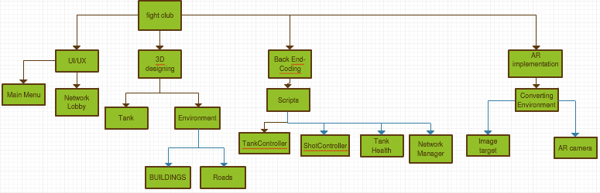
Figure 1: Work break down structure

Roles & Responsibility Matrix
The purpose of roles & responsibility matrix is to identify who will do what.
WBS # | WBS Deliverable | Activity # | Activity to Complete the Deliverable | Duration  (# of Days) | Responsible Team Member(s) & Role(s)
1. | Planning | Proposal | Proposal defence | 15 days | Hamza,Asim,Sajid
2. | Design GamePlay | Assets | Game Setup | 1 month | Hamza, Sajid
3. | Coding | C# code | Scripting of game | 1.5 month | Asim
4. | Network Coding | Networking C# | Multiplayer connections | 15 days | Hamza
5. | AR Converting | Convert game to AR | Convert the game to AR plateform | 15 days | Sajid
6. | Testing and debugging | Game test | Testing the game | 15 days | Hamza
7. | Implementation | Implement game | Deploy the game | 15 days | Hamza,Asim
8. | Documentation | Report | Making report | 15 days | Hamza,Asim,Sajid

Table 1: Roles and Responsibilities

Gantt Chart
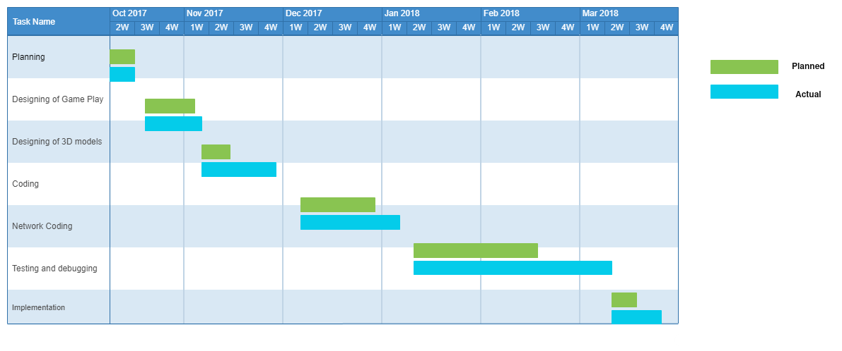Figure 2: Gantt Chart

Report Outline
- Background
- AR technology invention
- AR devices
- Usage of AR in industrial and commercial purposes
- AR tool kit
- AR applications
- Motivations and challenges
- Future of augmented reality
- AR in gaming industry
- Advancements in AR
- Goal and objectives
- Enhancement in AR
- Entertainment through AR
- Making interactive environment

- Existing solutions
- AR applications
- Market of AR
- Gap analysis
- Less functionality of AR
- Less multiplayer experience
- Proposed solution
- True augmented reality experience
- Traditional multiplayer feature
- Project plan
- Phases of development
- Work break down structure
- Roles and responsibilities
- Time line

Chapter 2

Software Requirement Specifications

Chapter 2: Software Requirement Specifications

Introduction
In this section the documentation of this report is specified. It specifies the purpose, document convention, document scope and also provides a suggestion for the readers of the document.

Purpose
The main goal or purpose of this document is to define the functionality and purpose of our game. This SRS include all the specifications like design, interface. There requirements and components. The main purpose of this SRS is to provide a complete understanding that what we are building and achieving in this game.

Document Conventions
The whole document is written in MLA format. Topics introduced in section and subsection headings in a bold text. Highlighting is to point out words in the glossary and italicized text and includes various diagrams like UML, ERD, DFD, CDSD etc.

Intended Audience and Reading Suggestions
Our project document has been done under the guidance of our supervisor and can be useful for any gaming development team. Student’s who wants to write document related to this project. After reading this project developer and project managers completely understand with SRS of this game. This SRS document ensures the game’s adherence of project manager to our original vision.

Product Scope
The product scope with the passage of time technology is advancing to the better way. Over the past century in the field of gaming there is a big enhancement occurring. Peoples want the technology that is more interactive revolutionary. This document includes the formal requirements of our game “Fight Club”. This document describes the system features and internal requirement specification of our game. In this era the industries willing to adapting full scale AR technology. This technology will increase become more presents in user’s daily life.

References
https://www.udemy.com/unity3d-create-an-augmented-reality-balancing-game/
https://code.tutsplus.com/tutorials/creating-ar-games-on-unity-using-vuforia-part-1--cms-27210
https://diyhacking.com/augmented-reality-app/
https://docs.unity3d.com/Manual/UNet.html
https://developer.vuforia.com

Overall Description
The overall description gives the detail about the whole features and systems of our project.

Product Perspective
The development of a software from nothing to it’s released position is an important physical act from any software development company. It has need of much money put into business in terms of hard work and price and also makes more fixed the belief person for whom one does work sense of being mixed up, knowledge about person for whom one does work market (example: Google play). We have got facts together some interesting articles from the web. The development of any software or game in software industry is an important goal of any software solution company.
Product Functions
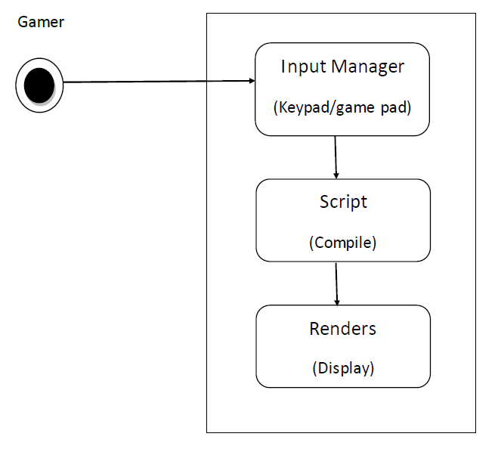
Figure 3: Product functions

User Classes and Characteristics
This is the role playing shooting game that kills the enemy tanks. It is requires to develop the tanks which will be the main characters of the game.

Operating Environment
These are the operating environments and software’s for our game “Fight Club”. Firstly we use two operating environments.
- IOS 7.0 and above
- Android 4.0 and above
We also used unity 3d for testing our game project “Fight Club”.

Design and Implementation Constraints
There are three stages to development of our game.
- Coding and scripting
In this stage we done the following things
- Scene setup
- Tanks creation and control
- Camera control
- Tank health
- Shell creation
- Firing shells
- Game managers
- Audio mixing
- Networking for multiplayer
In this stage we done the servers creation setup and develop connection scenarios for multiplayer system.
- Convert to AR
In this stage we have convert our game to AR technology.

User Documentation
The complete user documentation is provided on unity website tutorials.

Assumptions and Dependencies
We are assuming that the developed game will be working correctly with AR real world environment. The unity will be responsible for the construction of game and testing implementation.

External Interface Requirements

User Interfaces
All game has a menu so is can be user friendly enough and gamers can easily put into effect their need. The Menu is also an important thing while making come into existence the SRS document part. In this SRS document part; we have used the menu quick-shot in the user done. These quick-shots are based on the menu of the game.
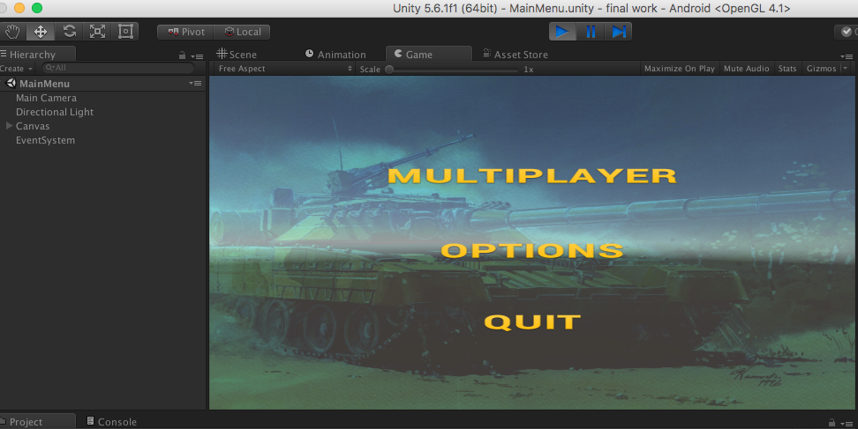
Figure 4: User Menu

Hardware Interfaces
“Fight Club” is built for mobile gaming and specially designed for android and IOS platform for the better far experience in game. Game locally stored in device storage and while developing the game we test and debug our game in Unity Engine as well as smart phone devices. This game is totally based on 3D environment so its uses the three-dimensional graphics library and OpenGL libraries as well as in hardware sense its uses the built-in GPU and ARM based CPU which control the performance and maintained the game application. Our game also uses the camera interface to create a visual 3D environment in a real time.
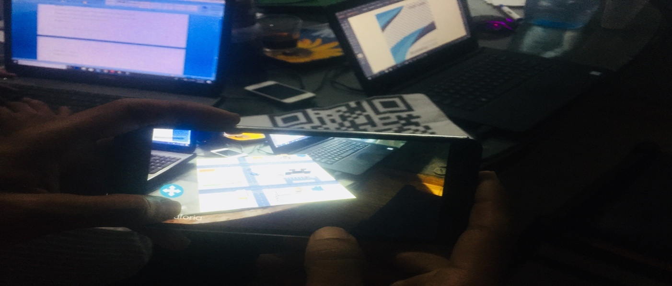
Figure 5: Hardware Interface

Software Interfaces
“Fight Club” has been developed using a series of game development tools.
Working tools and platform
- Unity3D
- Blender 3D
- Android Software development kit for applications on the Android platform.
- Xcode for the development of iOS applications.

Communications Interfaces
As we know this game is a Multiplayer game so this game must need an internet connection to play with other players. By hosting a server and connect a server you must need an internet connection. User can easily download this game from app store for android and iOS. In Android it smoothly runs in an Android Jellybean or above Android OS and for iPhone it suites iPhone 5 or above devices like iPhone X.

System Features
This System is designed in 3 layers:
- Main Menu
- Multiplayer Lobby
- Main Scene

Main Menu Functions

Description and Priority
It is the main and basic part of the function that directs to the other part of this game. It’s the first scene of our game called the User Interface of our game and the basic component of any game. It contains the following menus:
- MULTIPLAYER
- OPTIONS
- QUIT

Stimulus/Response Sequences
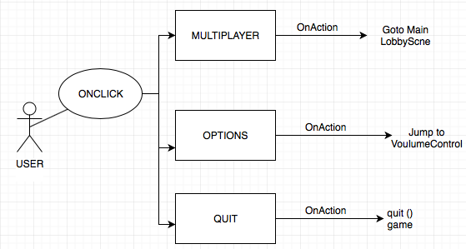

Figure 6: System Feature 1

Functional Requirements
This section contains all the functionality of the main menu in detail
REQ-SF1-1: By clicking MULTIPLAYER button scene jumps to the main lobby manager in which you create or join your game.
REQ-SF1-2: By clicking option you get jump through the volume control
REQ-SF1-3: By clicking quit button game terminates.

Multiplayer Lobby

Description and Priority
This game scene contains the Network lobby management in which user host the server and join the server in a lobby.

Stimulus/Response Sequences

Figure 7: System Feature 2

Functional Requirements
One user must create the server to join the game otherwise game will not be play.
REQ-SF2-1: by creating server user can host its server and able other players to join with him.
REQ-SF2-2: by joining server you see the list of server hosted and after connect with your selected server to join and play the game. Before joining its necessary any player hosting the game

Main Scene

Description and Priority
This main scene contains the complete game environment and our player this is the final scene and core of the game without it it’s not possible we play a game

Stimulus/Response Sequences

Figure 8: System Feature 3
      - Functional Requirement
For the movement of the tank it’s necessary to require a controller to fire and for the movement of player tank.
REQ-SF2-1: touch the virtual joystick trigger the fire function of a tank
REQ-SF2-1: By rotating the joystick Tank changes his axis.

Other Nonfunctional Requirements

Performance Requirements
We can use 5 different methods for boosting game’s performance.
- Reduce scene load time
- CPU optimization
- Object polling
- Profiler
- Using check list
With the help of these five methods we can achieve maximum performance of our game in unity 3d.

Safety Requirements
We must need QR code page for playing our game in real world environment with AR. Must have light environment where we run our game in real world environment.

Security Requirements
We used HTTPs connection for traditional games. The internet connections are not secure because hackers can steal your information from mobile phone and they get information from operating systems in which running your game. The speed Hat allows your avatar move faster than other player. The strong advantage of our game is we are not using the accounts creation and information getting services. In our game user just create the server room and other user can connect with these servers. We are not using any third party connection for our game. We are using traditional gaming TLS connection in which the server generates a random number once and directly send to client for connection. The user have no need to submit passwords for connection. The many popular games of multiplayer networking are using this connection service.

Software Quality Attributes
The software quality attributes for our game is
- Performance
Firstly we enlist the resources that are used for our project.
- Cpu
- Memory
- Network bandwidth
- Disk space
There are two types of performance time. 1) feed back time 2) feed through time
- Availability
In this section describe what the time are consume for multiplayer connectivity and playing the game. This is improved by testing the game and reduced the time of multiplayer connectivity.

- Correctness
How the game functions are implemented successfully. When deploying our game the amount of bugs and errors produce in our game.
- Usability
What is the mechanism which we provide for game playing.
- Testability
The number of tests in testing phases and also time required for testing. There are many test mechanisms that we are used for our game testing.
- Security
Controlling the cheat mechanisms in online game.

Other Requirements
We have covered almost all the necessary requirements for our document. There are no other requirements of our game project “Fight Club” that we are using in our game.

Chapter 3

Use Case Analysis

Chapter 3: System Analysis
This chapter describes the system analysis and models of our game system. These models tell us how the user interacts with the system and what the sequence of activities that occur as the software is used.

Use Case Model
The below table summarize the use case model of our system.

Level – 0 | Level – 1 | Level – 2
Game ( Fight Club ) | Multiplayer | Create Game
Game ( Fight Club ) | Multiplayer | List Servers
Game ( Fight Club ) | Multiplayer | Direct Connect
Game ( Fight Club ) | Multiplayer | Back
Game ( Fight Club ) | Options | Change Sound/  Music Volume
Game ( Fight Club ) | Options | Back
Game ( Fight Club ) | Quit

Table 2: Use cases

Use Diagram and Use Case Descriptions
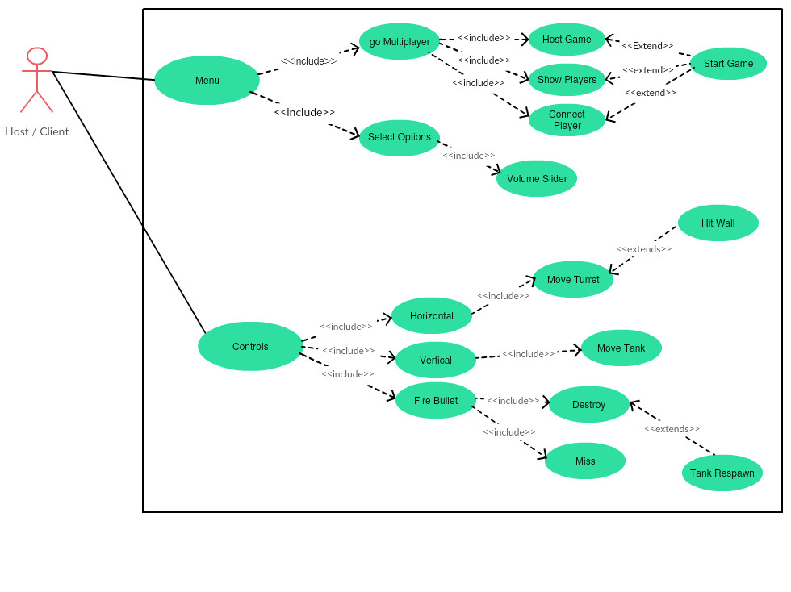
Figure 9: Use Case Diagram
Use Cases Descriptions

The use case descriptions is
Multiplayer
i.
Use Case: Create Game
Primary Actors: Hosting the game
Goal in context: To create a new server in lobby
Precondition:
- System supports the game configuration
- The file has been triggered to create a server and lobby screen has appeared
Triggers: The player needs to host a new game
Scenario:
- Go to main menu of the game
- Click multiplayer button
- Network lobby is loaded on system
Exception: Game crushed
ii.
Use Case: List Servers
Primary Actors: Anyone playing the game
Goal in context: To show servers and join the game
Precondition:
- Server was created before
- Game must have a internet connection
Triggers: Need to join server
Scenario:
- Go to main menu of the game
- Click multiplayer button
- Network lobby is loaded on system
- Must have internet connection
- Join the server in network lobby
- Ready the player to start a game
Exception:
- Servers cannot be loaded
- Problem in server connection
- Game crushed
iii.
Use Case: Direct Connect
Primary Actors: Anyone playing the game
Goal in context: To directly join the game server
Precondition:
- Must have server address
- Must have internet connection
Triggers: Need to join a server
Scenario:
- Go to main menu of the game
- Click multiplayer button
- Select direct connect
- Enter ip address for server
Exception:
- Wrong ip address
- Server cannot be connected
- Game crushed
iv.
Use Case: Back
Primary Actors: Anyone playing the game
Goal in context: To exit from network lobby
Precondition: Must be in network lobby
Triggers: Player needs to exit from network lobby
Scenario:
- Go to main menu of the game
- Click multiplayer button
- Network lobby is loaded on system
- Click back button
Exception: Game crushed
Options
i.
Use Case: Change Sound/ Music Volume
Primary Actors: Anyone playing the game
Goal in context: To change the sound or music volume
Precondition: Player is allowed to change volume of game
Triggers: Player has need to change volume of the game
Scenario:
- Go to main menu
- Click on options button
- Click on sound slider and change the value
- Music or sound volume is changed
Exception: System is mute mode, cannot increase volume
Quit
i.
Use Case: Quit
Primary Actors: Anyone playing the game
Goal in context: To exit from the game process
Precondition: Player has entered in the game process
Triggers: Player needs to exit the game
Scenario:
- Go to main menu
- Click Quit button
- Game is exited
Exception: Something went wrong. Cannot exit now

Chapter 4

System Design

Chapter 4: System Design
This chapter describes about the system design of our game. This will include the different types of diagrams. These are eleven different types of diagrams of software engineering which we are using for detailed design of our game project “Fight Club”.

Architecture Diagram

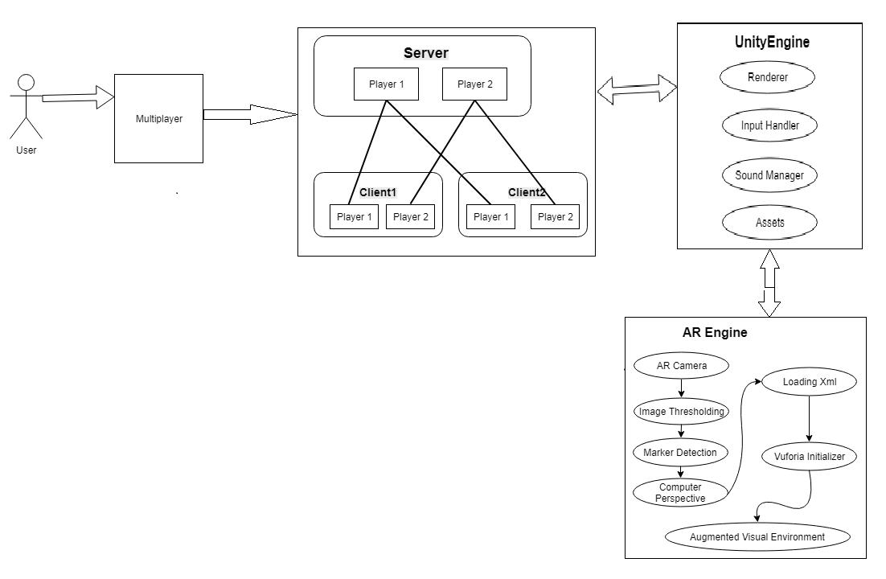

Figure 10: Architecture Diagram of game

Entity Relationship Diagram with data dictionary
The entity relationship diagram is not applicable for our project fight club because we are not save any type of data in our database server.

Class Diagram

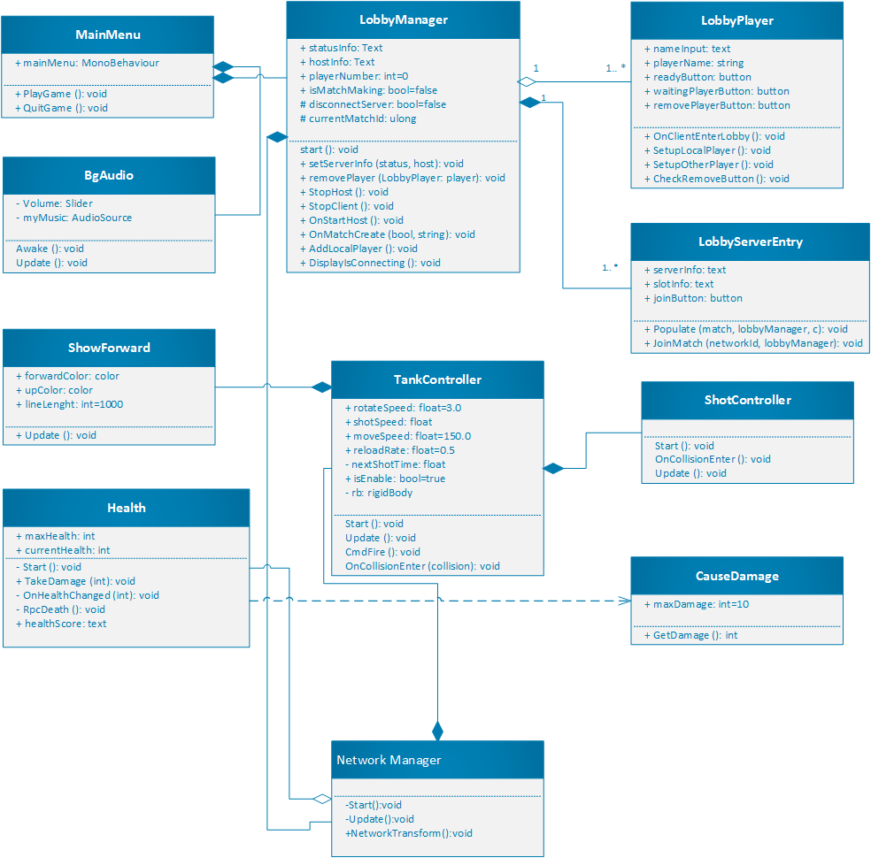

Figure 11: Class Diagram

Sequence Diagram
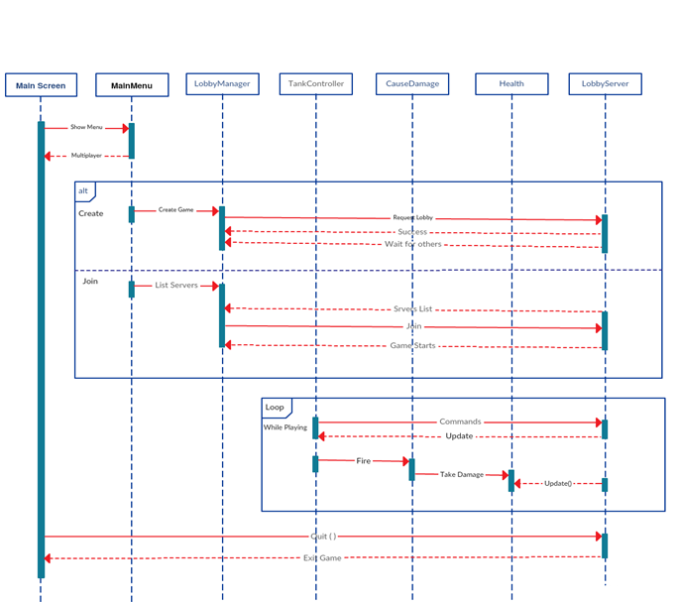

Figure 12: Sequence Diagram

Activity Diagram
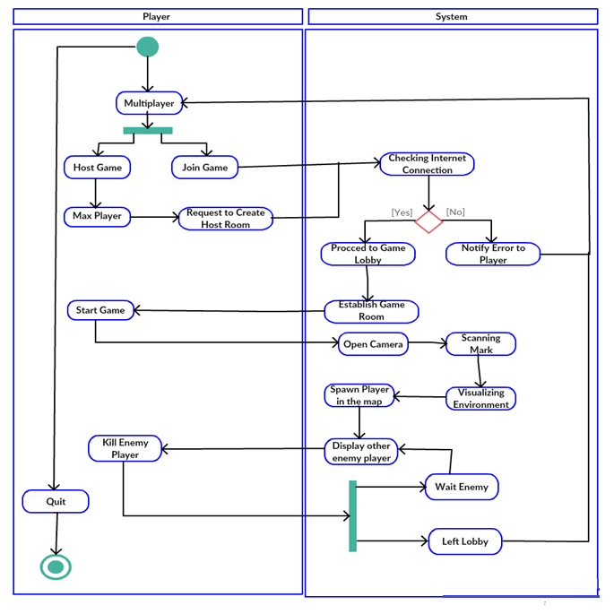
Figure 13: Activity Diagram

Component diagram
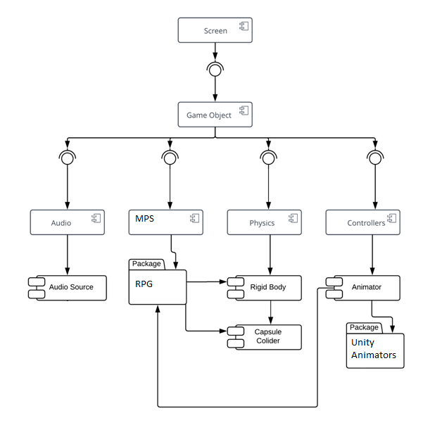
Figure 14: Component Diagram

Data Flow diagram
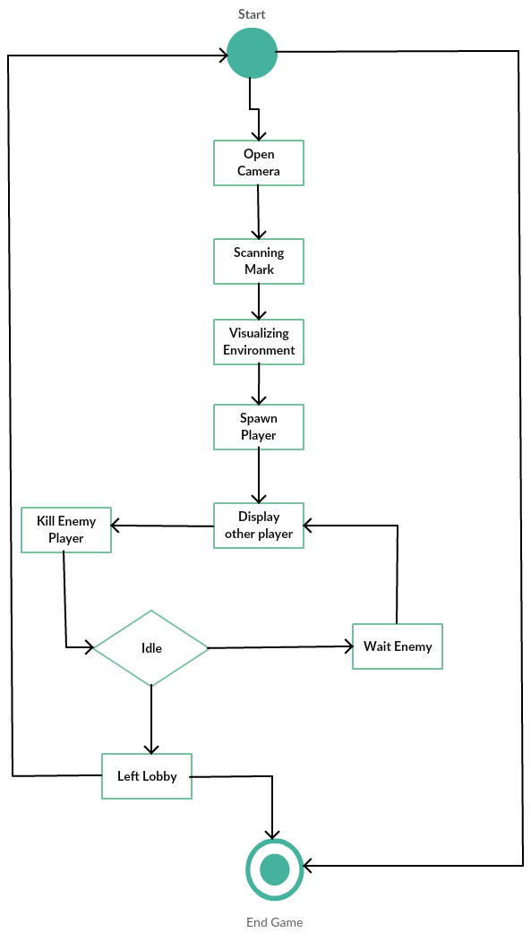
Figure 15: DFD

Chapter 5

Implementation

Chapter 5: Implementation
This chapter covers the implementation of our project features and implementation flow control of our game. This chapter also describes the components, libraries and web services used in our game project. The deployment environment, tools and techniques and coding standards are explained in this chapter that we are using in out game project.

Important Flow Control/Pseudo codes
We use agile method software engineering technique for developing our project.

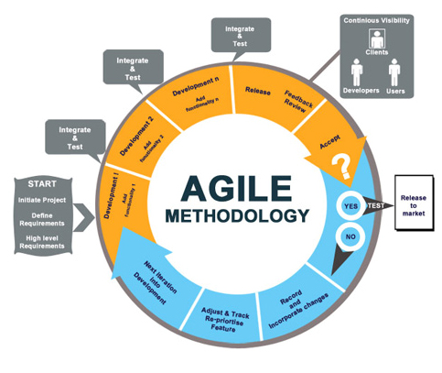
Figure 16: Agile Diagram

Components, Libraries, Web Services and stubs
The Unity components we are used in our game
Mesh
- Mesh filter
- Text mesh
- Mesh renderer
Effects
- Trail renderer
- Line renderer
- Lens flare
- Hallow
Physics
- Rigid body
- Box collider
- Sphere collider
- Capsule collider
- Wheel collider
Navigation
- Nav mesh agent
- Off mesh link
- Nav mesh obstacle
Audio
- Audio source
- Audio listener
- Audio low pass filter
- Audio high pass filter
Rendering
- Skybox
- Gui layer
- Flayer layer
- Light
- Light prob group
- Light prob proxy volume
Layout
- Canvas
- Canvas group
- Canvas scaler
Scripts
- Camera control
- Game manager
- Tank lobby
- Tank manager
- Shell explosion
- Tank health
- Tank movement
- Tank setup
- Tank shooting
Network
- Network identity
- Network lobby manager
- Network lobby player
- Network manager
- Network manager HUD
- Network transform
User interface UI
- Text
- Image
- Button
- Input field
- Slider

AR
- AR camera
- Image target
Libraries
The unity libraries we are used in our game
First we are using unity libraries
- System
- Unity engine
- System.Collections
- DLLTest
- System.Collections.Generic
- UnityEngine.Networking
- UnityStandardAssets.CrossPlateformInput
- UnityEngine.Ui
- UnityEngine.SceneManagement
- UnityEngine.Audio
Web Services
We used unity multiplayer web services.
- Unet multiplayer service
The Unity system supports most Unity platforms
- Nintendo Switch
- All versions of the Editor and Standalone players
- Mobile platforms: iOS, Android
- WebGL
- Universal Windows Platform

This opens the Multiplayer Services window.
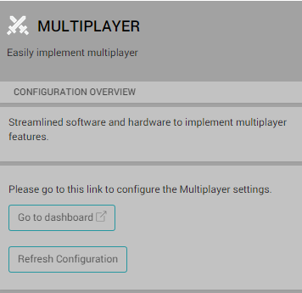
Figure 17: Multiplayer services
The Stubs of our project “Fight Club” is that
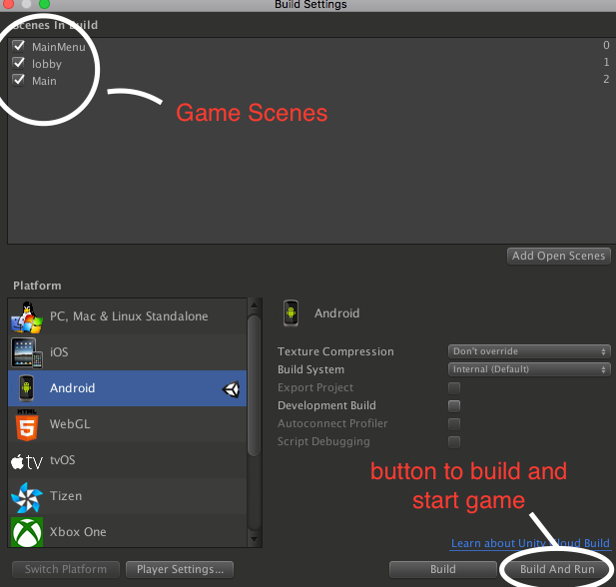
Figure 18: Stub

Deployment Environment
We can deploy our game in any environment but firstly we deploy on android and IOS operating systems. We can potentially deploy our games to a greater variety of devices from tablets to gaming consoles to the latest emerging technologies built around Windows 10 and mobile phone operating systems.

Tools and Techniques
Product: Unity Technologies
Tool: Unity 3d
Usage: Game Engine
Work Experiment: Backend and frontend Activity

Product: Blender
Tool: Blender 3d
Usage: 3d models and environment
Work Experiment: To create 3d models
Product: Adobe
Tool: Adobe illustrator
Usage: Create brouchers and templates
Work Experiment: To create brouchers, templates and flayers for report

Product: MonoDevelop
Tool: Mono develop
Usage: Game coding and c# scripting of game
Work Experiment: Game working and backend coding implementation

Best Practices / Coding Standards
Naming Conventions
The naming conventions in unity we used
Variables: begins with the lowercase letters. The variables are used to store the game information about any aspects of any state of game.
Classes: Classes are declared with the uppercase letter. The classes are the collection of functions.
Functions: Functions are starts with uppercase letters. Functions are collection of code and they are written once and they can be used as they need in programe.
Scenes
Save: The scene by selecting File->Save As and give the game a name
Indentation
- Emphasize the body of a control statement such a loop or a select statement
- Define the body of a conditional statement
- Define a new scope block
- Three spaces minimum used to indent
Inline Comments: Inline comments explaining the functionalities and codes of the game development
Use of Braces
- Braces are used to delimit the bodies of conditional statements, control constructs, and blocks of scope.
- Braces shall be used even when there is only one statement in the control block.
Compiler Warnings
- Compiler and linker warnings shall be treated as errors and fixed because they often indicate problems which may affect the behavior, reliability and portability of the code.
- The options fully enable the compiler’s code-checking features.
Line Length: Line lengths cannot exceed 72 columns.
Spacing:
- A keyword followed by a parenthesis should be separated by a space.
- A blank space should be appear after each comma in an argument list.
- Casts should be made followed by a blank space.
Wrapping Lines:
- Break after a comma
- Break after an operator
- Prefer higher level breaks to lower level breaks
Variable Declarations: Variable declarations should always be preceded by multiple lines.
- Coding for efficiency
- Coding for readability
- Meaningful error messages
- Reasonably sized functions and methods

Version Control
Unity provides us services to build our game as a team in a different ways but rather than using this we individually complete our tasks in our separate machines and the finally joined all this and build game in a one single machine in which our complete project is up and running. For further any update we fix this issue in the same way we did before.

Chapter 6

Testing and Evaluation

Chapter 6: Testing and Evaluation
This chapter includes some test cases for the game to check if the game works properly in various situations. We are giving four test examples for eight different situations here. In this whole chapter we check each aspect of game according to its performance and appearance. Testing each part of the game part give us a detailed report of our game which gives us a better understanding of game and its life cycle.

Use Case Testing
In use case testing we generally test our game covering all aspects.

User Interface(UI) | TEST in Landscape/Portrait mode
 | TEST for animation, movement of character, graphics, Zoom In/Out (all gestures) etc.
 | There should not be any clipping (cut background)
 | Test if there is no overlapping of objects
 | Character should not move out of the screen/specified area
 | Test for enable and disable images/icons/buttons etc
 | Font displayed (color, size etc)
Performance during game | TEST the loading time of a game
Core structure of game | TEST game area, game logic
 | Menu options
Multiplayer Functionality in game | Session expiry test
 | Test when player 2’s turn is on Player 1 is not able to do actions (should not be able to forfeit also)
Memory leak | Check the game when device memory is low
Check for localization | Should be Support of different languages
Device , OS | Check in supported screen sizes and os versions (basicaly depend upon Client requirement)

Table 3: Use Case Testing

Equivalence partitioning
Invalid | Valid | Invalid
Tank Health < 1 | Health in between 1-100 | Tank Health > 100
Move speed < 100 | Move Speed = 100 | Move Speed >100
Shot Speed > 50 | Shot Speed = 50 | Shot Speed < 50
Reload Time > 0.5 | Reload Time = 0.5 | Reload Time < 0.5
Spawn Points in level > 4 | Spawn Points in level = 4 | Spawn Points in level < 4
Fire Damage > 10 | Fire Damage = 10 | Fire Damage < 10
Lobby players > 3 | Lobby players 1 – 3 | Lobby players < 1

Table 4: Equivalence Partitioning

Boundary value analysis
Invalid (min-1) | Valid (min, +min, -max, max) | Invalid (max+1)
Tank Health (-1) | Health in between (1-100) | Tank Health (101)
Move speed (1-99) | Move Speed = 100 (100) | Move Speed (101)
Shot Speed (-49) | Shot Speed (50) | Shot Speed (51)
Reload Time (0.4) | Reload Time (0.5) | Reload Time (0.6)
Spawn Points in level (3) | Spawn Points in level (1-4) | Spawn Points in level (5)
Fire Damage (9) | Fire Damage (10) | Fire Damage (11)
Lobby players (0) | Lobby players (1 – 3) | Lobby players (4)

Table 5: Boundary Values

Data flow testing
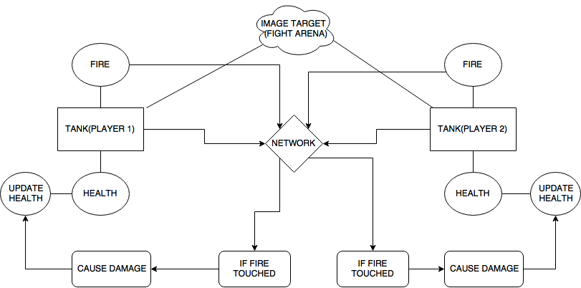
Figure 19: Data Flow Testing

Unit testing
With the help of unity testing you can avoid from stupid bugs and write a sustainable code for your application. By using unit testing you get the early feedback through series of tests and avoid any type of regression in game and enrooted to object oriented design and create during documentation of your code.
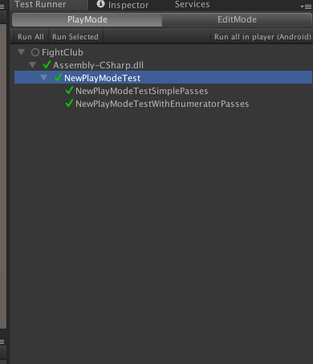
Figure 20: Unit Testing
Unity itself provides the features of unit testing of game in its tool. So we ran our script tests for the betterment and find there is no error to be fixed in this code all the scripts to be tested and unity made them clear.

Integration testing
Our game consists of total 3 scenes we test all the scenes step by step
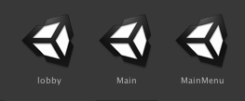
In first Scene that is based on UI we test all the buttons and their respective trigger action
In second scene which is based on the network lobby which includes the creation of server and joining of server is test individually.
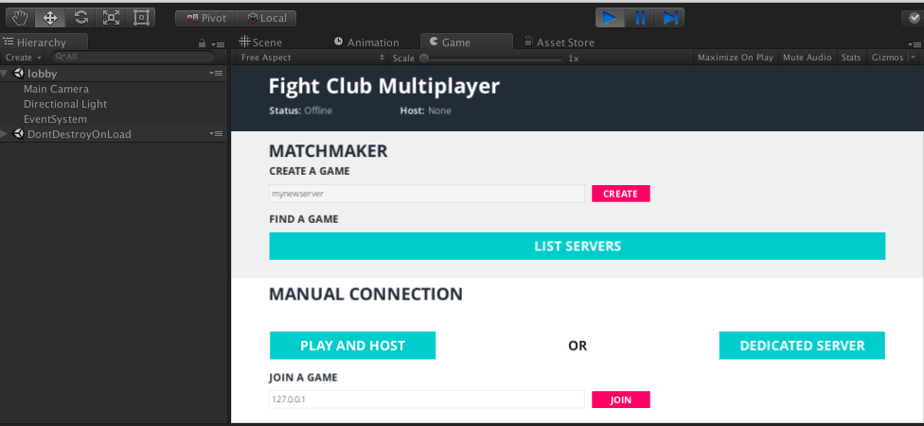
Above interface includes all the fields to create the server join the server and show the list of complete servers.
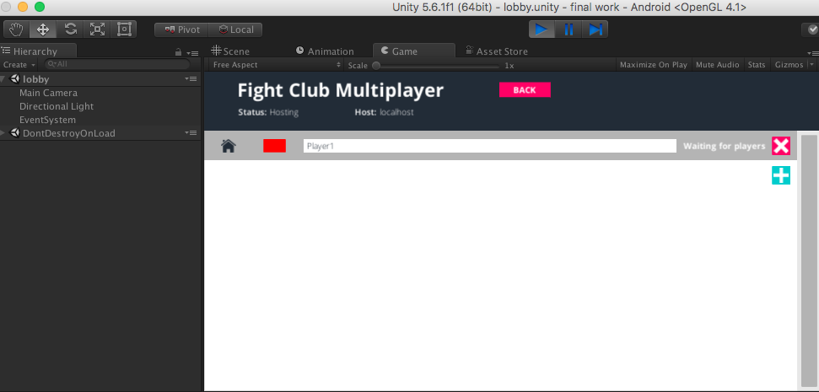
By creating server we test our network lobby manager.
Third and Last Scene are the main and final scene of the game that includes the main environment of game in which user can play with each other in a augmented reality environment but for testing we run it in a non-AR environment.
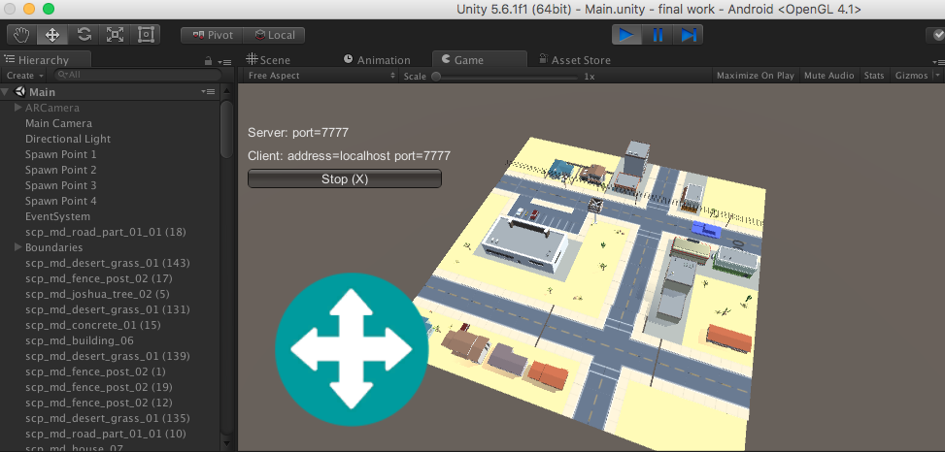
The above image show that our player successfully hosts the server and spawn our player in a map

Now we test it in a AR environment
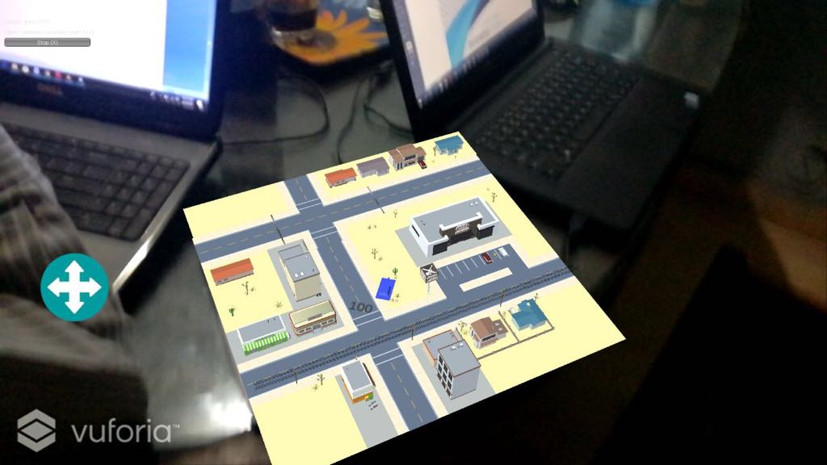

Performance testing
For testing the performance of our game unity itself provide a feature to test the performance of your game using profiler. It can test the gpu and cpu requirement of your game and displays the result right away when you play it in the unity. We can test the CPU usage, rendering unit, memory consumption and many other related things.
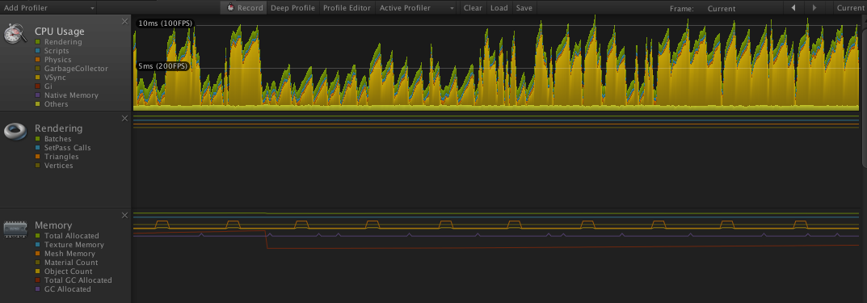
Figure 21: Performance Testing

Stress Testing
In this testing we test the strength of a software by pushing to its limits so that we can came to know about how much this software goes far. In our game we ran a series of test in the unity to test the network stability of game and conclude that how much our network system bear the network clients in the game we ran through different devices hence our lobby have only space of three clients so we test it in different 3 platforms.
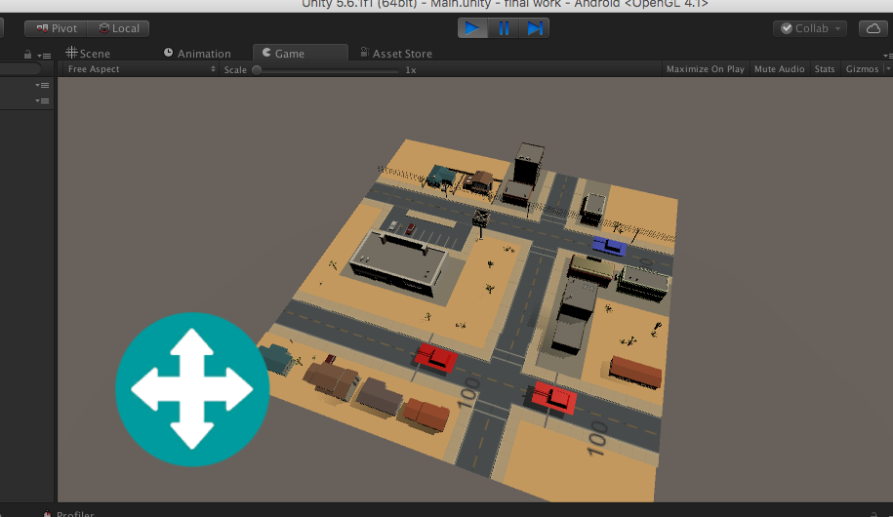

Figure 22: Stress Testing

Above image show that the all three players is perfectly spawned on there position and causes a no network issue.
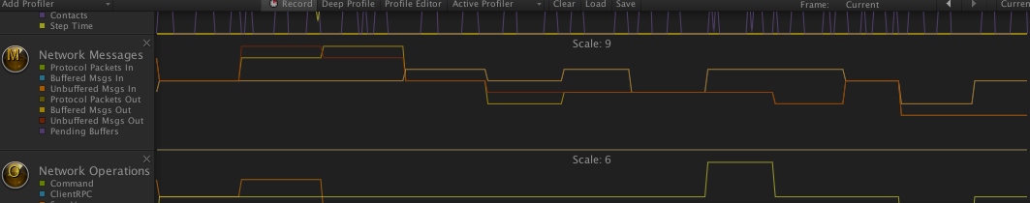
Above graph show the transfer of data packets and any type of buffers during multiplayer game.

Chapter 7

Summary, Conclusion and Future Enhancements

Chapter 7: Summary, Conclusion & Future Enhancements

Project Summary
A multiplayer shooting game based on augmented reality environment in which users can play with each other in a same map by scanning a mark with the help of their mobile camera which create a visual environment in a real time in which user can rotate and fire their tank and battle against each other. By using the augmented reality, we cut the method of old traditional mobile gaming which is limit to only screens. This game is affordable for almost everyone and easily be used and create a very interactive and fun environment among the players.

Achievements and Improvements
During this process of game development we learnt a lot of skills like :-
- Unity Engine Understanding
- Working with a 3D objects
- Creating an Environments
- Best Coding practices
- Physics
- Dimensions
- C# scripting
- Object oriented coding
- Building and running mobile games in various environments
- Exposure in a gaming field
- Logic behind gaming
- UI/UX designing
- Working with augmented reality in a Unity 3D environment
- Networking fundamentals
- Implement multiplayer feature in a game.
- Creative thinking
These are the achievements and improvements we think we learn so far from this final project and that takes our interest in gaming to take pursue our future with this field.

Critical Review
Fight Club is first of it’s kind that provide the multiplayer augmented reality feature so its takes time to be completely stable. In sense of its networking with servers and among other players its work in a complete normal way but due to increasing of server rooms and players it might be cause some disturbance with the networking.

Lessons Learnt
We absorb very much from this project. This project sharpens our skills in Unity Game Engine, designing tools and many management concepts as well as how to deal with a problem and how to stick for finding the solution of any problem until you fond. As well as technical skills this project also enhance our personal development skills such as team working, dedication. We learnt various types of techniques in gaming development for the creation of game. Our passion of making a unique game that contains the enjoyment element in an innovative environment and we succeeded it. We continue our work after this to make it through worldwide. This project is a stepping stone for us in the beginning we don’t even know that if we accomplished it or not but due to our hardworking and research we do it and it’s an achievement for us that motivates us to do better and more.

Future Enhancements/Recommendations
So generally, there are many enhancements we want to put in our game i.e.
- Enhance the visual of game
- Adding various maps in game
- Adding a survival mode
- Increase the performance of game
- Make our network servers in a large scale according to user rate
- Adding new tanks
- Create a competition between players.

Appendices

Appendix A: User Manual
In the appendix section we describe the different phases of user interface and also describe how user can use our project. Secondly we describe our promotional plan and promotional materials like broucher, banner, standee and other marketing materials. We also describe other interfaces of our game project.
Appendix A: Menu
Multiplayer
This is the first interface of our game which is based on the menu screen. In this interface user can select a menu for using game feature and playing or processing our game.

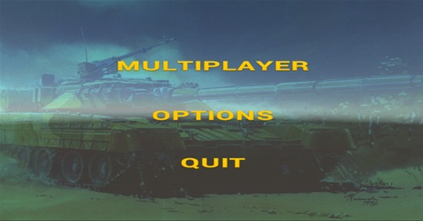
  - Create Game
In this section user can create a lobby for hosting a game and give the space to other users in lobby to join the new game.
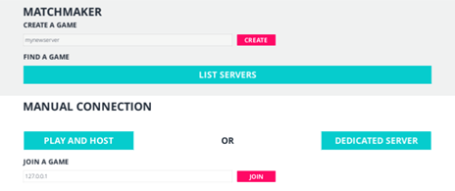
    - Join Player
In this section user is waiting for another players to join his lobby or server room for playing the game.

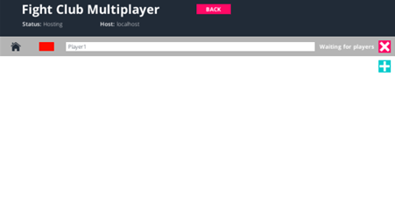
      - Ready
In this section player is connected to other players and ready for playing the game. Player can connect one player or multiple number of players to play the game.
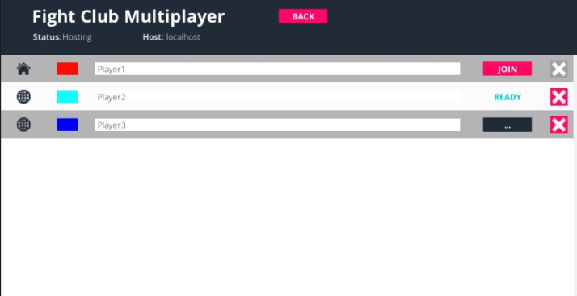

Appendix A: Menu
Multiplayer
This is the first interface of our game which is based on the menu screen. In this interface user can select a menu for using game feature and playing or processing our game.

  - List Servers
In this section user can view the server by clicking on view button. Servers are already created.

    - Join And Ready
In this scenario user can enter the server lobby don’t need to create game because other user created the server lobby. User only view the list of server and can connect any of the server is available for connection.

A.1.1.1. Game Play
User joined the server and ready to play the game in real time environment.

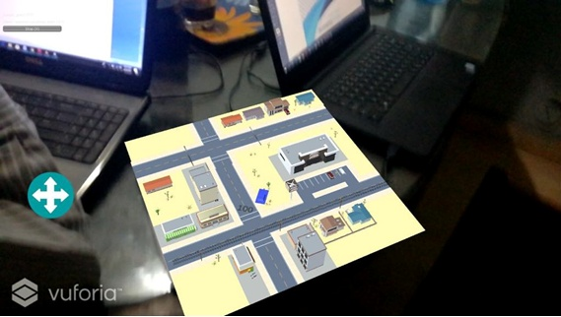

Appendix A: Menu
Multiplayer
This is the first interface of our game which is based on the menu screen. In this interface user can select a menu for using game feature and playing or processing our game.
A.1. Join
In this scenario user can directly connect a player through ip address.

A.1.1. play
User joined the player through ip address and ready to play the game in real time environment.

Appendix A: Menu

Options
This interface describes the options menu in our game project.
  - Volume Change
The options menu is specified for volume change.


Appendix A: Menu

Quit
This scenario is used for leaving our game.

Appendix B: Administrator Manual
There is no administration manual for our game project “Fight Club”.

Appendix C: Information / Promotional Material
This chapter describes about the promotional material that we used for promotion of our game “Fight Club”

  - Broacher

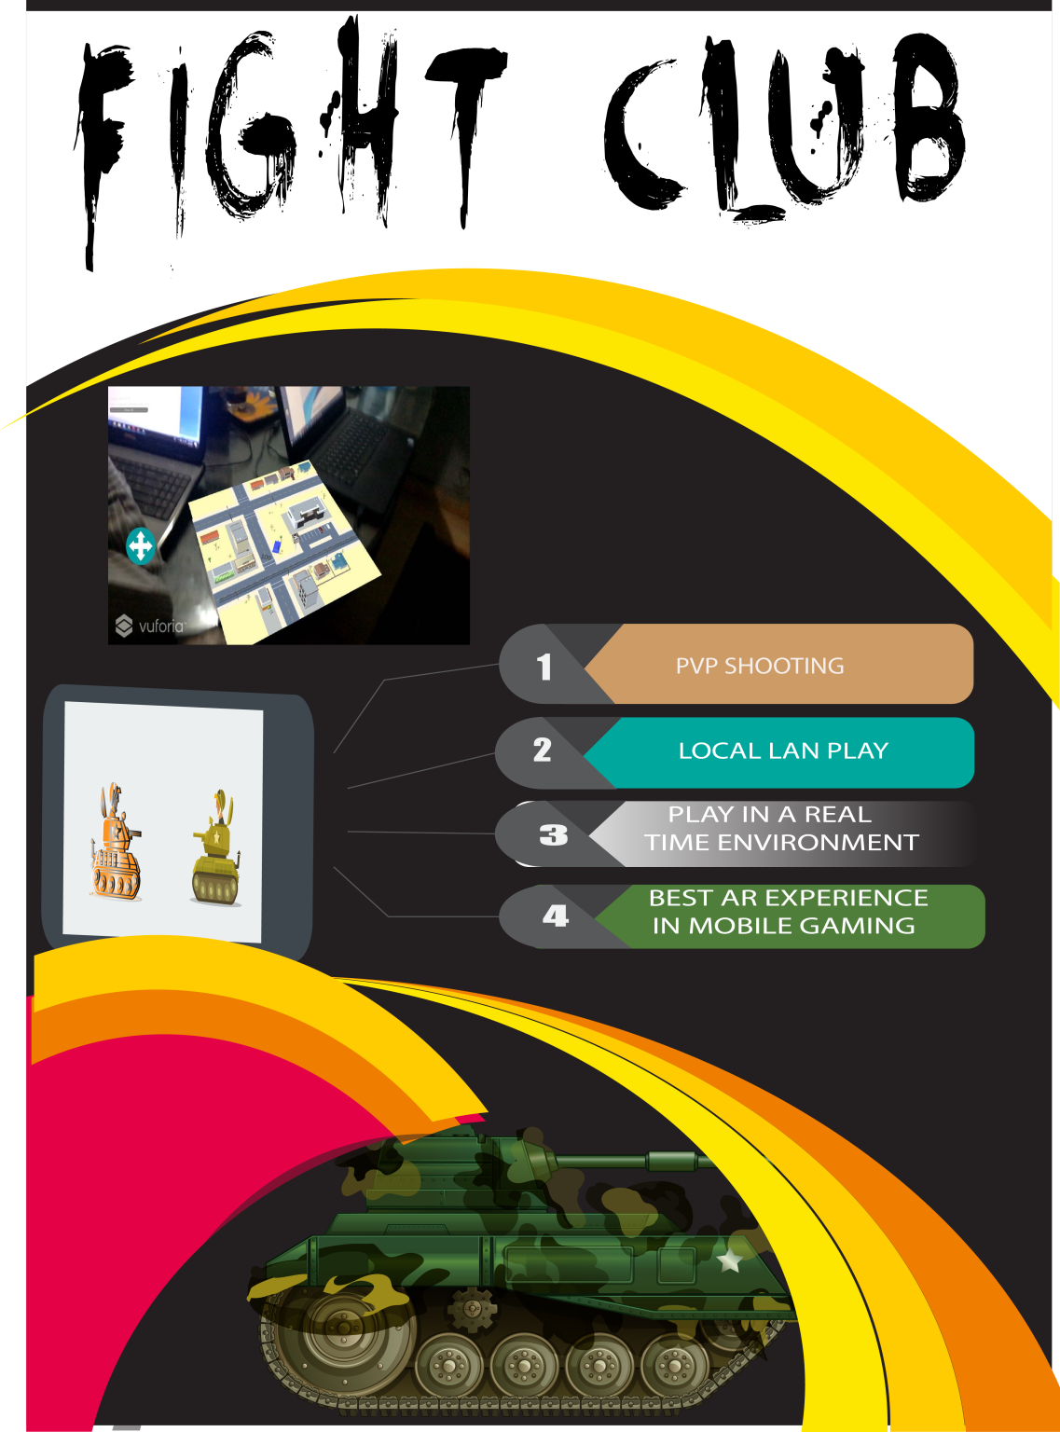

  - Flyer
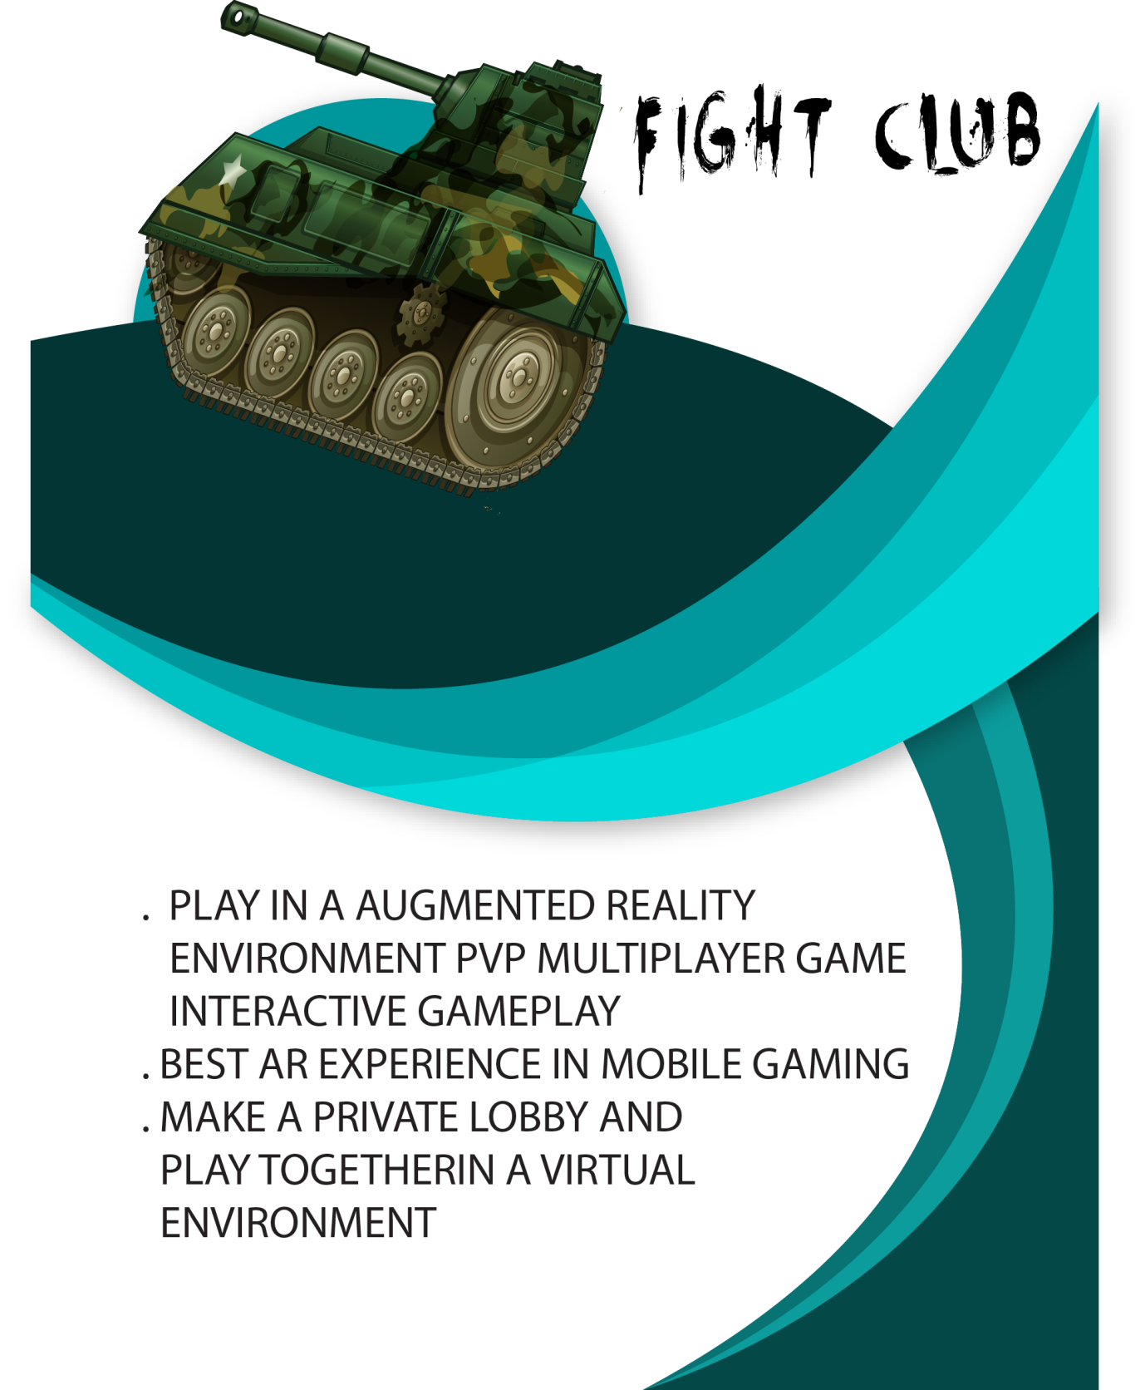

  - Standee
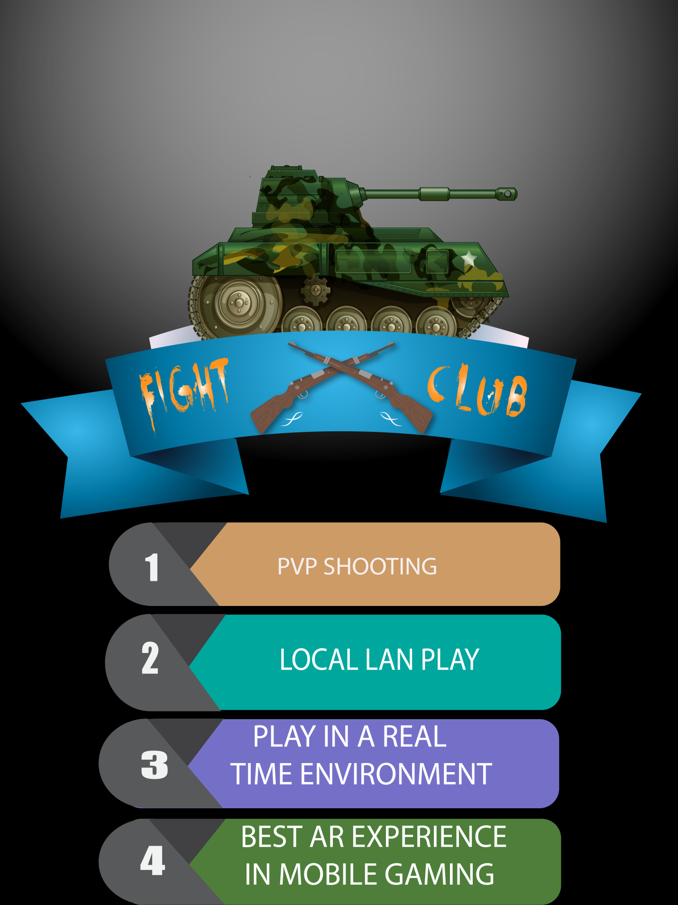

  - Banner


Reference and Bibliography

Reference and Bibliography

[1] Jani Ahde, “Real time unity multiplayer server implementation” Xamk/China, 2017.
[2] Artem Moskalev, “Multiplayer game and software architecture” University of applied sciences/Helinski, 2014.
[3] https://creately.com/diagram/example/hr8jv8lr1/Puzzle%20Game%20Domain%20Model
[4] https://docs.unity3d.com/Manual/SwitchingDocumentationVersions.html
[5] https://docs.unity3d.com/Manual/UNetOverview.html

